**AIM:**

To implement **Prim’s Algorithm** in C to find the **Minimum Spanning Tree (MST)** of a weighted undirected graph.

**📘 PRIM’S ALGORITHM OVERVIEW:**

1. Start with any vertex and include it in the MST.
2. At each step, pick the **minimum weight edge** that connects a vertex in the MST to a vertex outside the MST.
3. Repeat until all vertices are included.

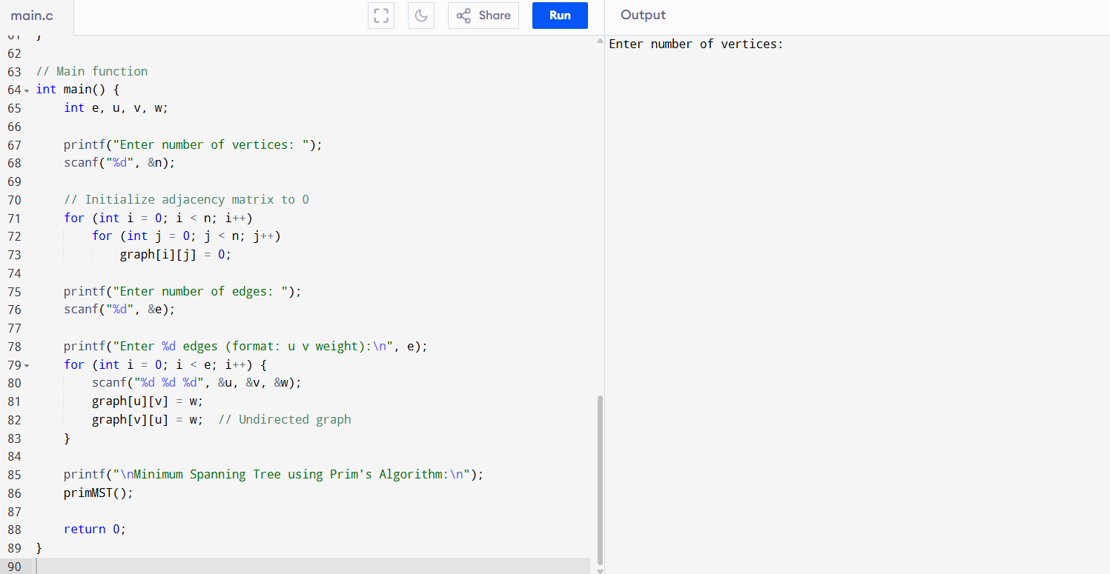

**SAMPLE OUTPUT:**

Enter number of vertices: 5

Enter number of edges: 7

Enter 7 edges (format: u v weight):

0 1 2

0 3 6

1 2 3

1 3 8

1 4 5

2 4 7

3 4 9

Minimum Spanning Tree using Prim's Algorithm:

Edge Weight

0 - 1 2

1 - 2 3

1 - 4 5

0 - 3 6

Total weight of MST: 16